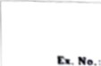 GE231Jl • Programming C

Date:

palindrome Number

Write •n Algorithm draw nowehart to Whether the given number is

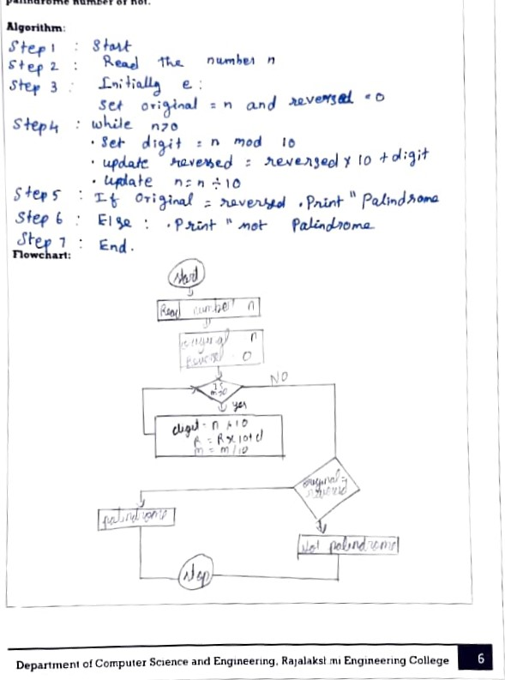

palindrome

number

not.

|  |  |
| --- | --- |
| 0r23 | 3 | •「,。Ⅷ gu· gC |



